G.Guna Sundeep – 19R11A04M2 – ECE2E

#include "BluetoothSerial.h"

#if !defined(CONFIG_BT_ENABLED) || !defined(CONFIG_BLUEDROID_ENABLED)

#error Bluetooth is not enabled! Please run `make menuconfig` to and enable it

#endif

BluetoothSerial SerialBT;

int echopin=4;

int trigpin=5;

const char tapon='turnon';

const char tapoff='turnoff';

void setup() {

pinMode(echopin,INPUT);

pinMode(trigpin,OUTPUT);

pinMode(2,OUTPUT);

Serial.begin(115200);

SerialBT.begin("ESP32test");

Serial.println("The device started, now you can pair it with bluetooth!");

}

void loop() {

char ledinfo=SerialBT.read();

if (ledinfo==tapon)

{

digitalWrite(2,HIGH);

}

if (ledinfo==tapoff)

{

digitalWrite(2,LOW);

}

digitalWrite(trigpin,HIGH);

delay(1000);

digitalWrite(trigpin,LOW);

int duration=pulseIn(echopin,HIGH);

int distance=duration*0.0343/2;

if (distance<=20)

{

Serial.println("Turn off ASAP");

Serial.print("level = ");

Serial.println(distance);

SerialBT.println("Turn off ASAP");

SerialBT.print("level = ");

SerialBT.println(distance);

}

else if (distance>20)

{

Serial.print("level = ");

Serial.println(distance);

SerialBT.print("level = ");

SerialBT.println(distance);

}

delay(1000);

}

( APPLICATION LAYOUT IS ATTACHED BELOW)

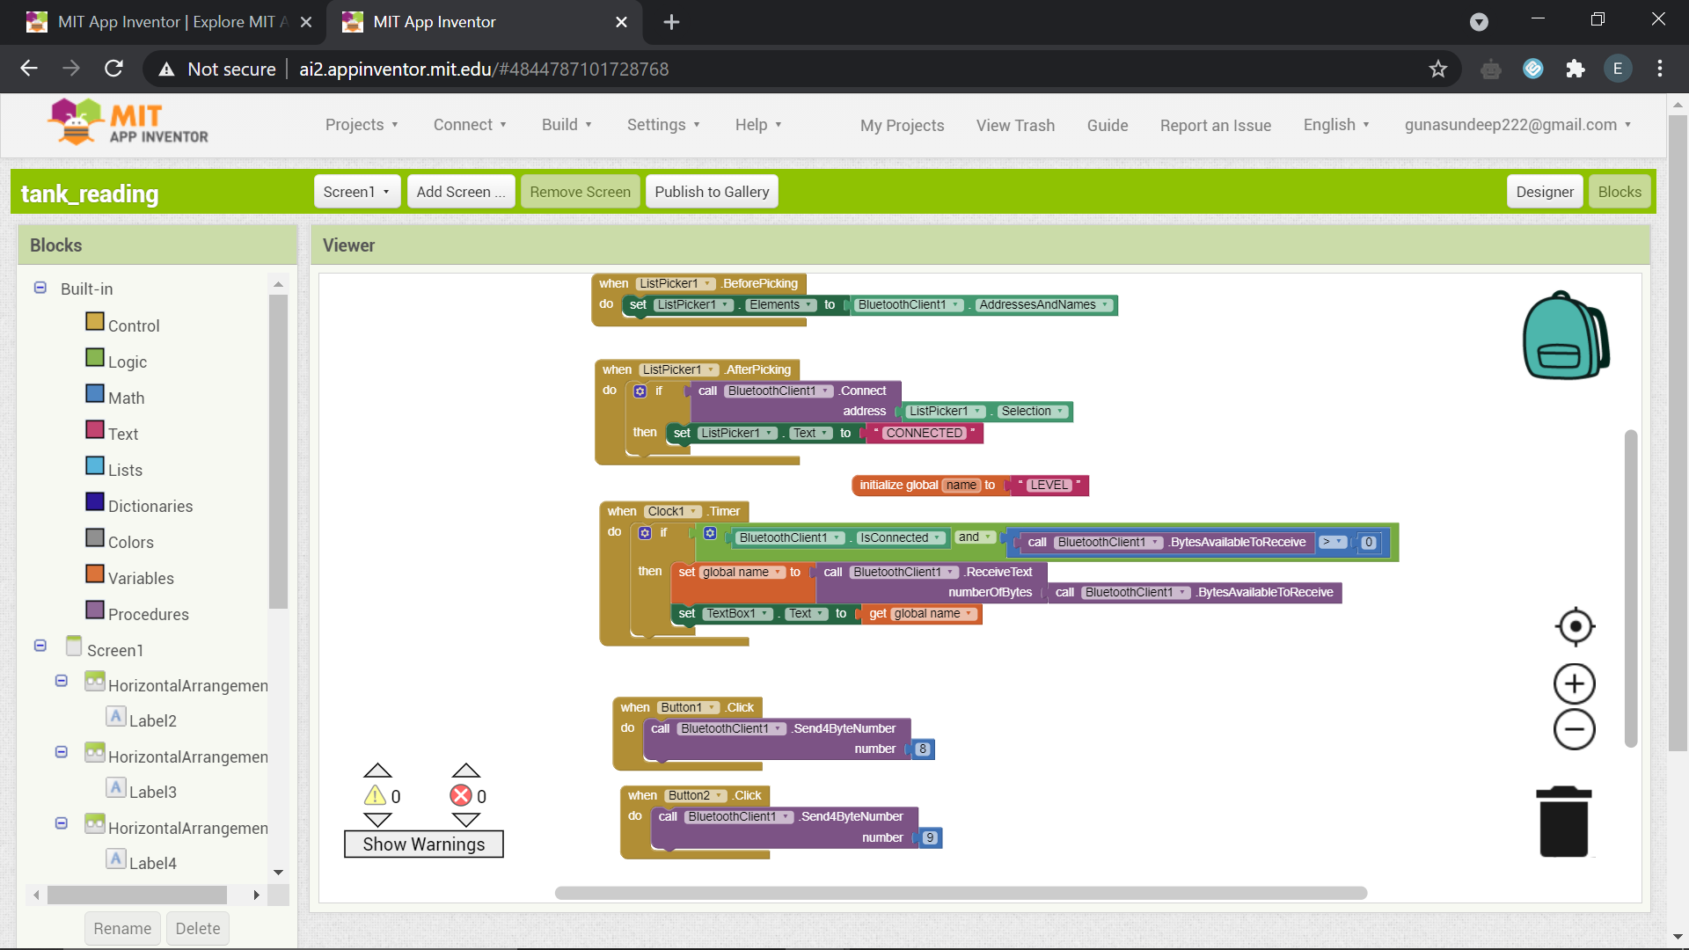

( APPLICATION LAYOUT IS ATTACHED BELOW)

